**Hackathon Project Phases Template**  for the **AutoSage App** project.

**Hackathon Project Phases Template**

**Project Title:**

**AutoSage App Using Gemini Flash**

**Team Name:** **Gemini flash**

**Team Members:**

* PAMULAPATI GNANA SREE
* Pakanati Ashwitha reddy
* shivani panadwad
* Papaiahgari madhuri

**Phase-1: Brainstorming & Ideation**

**Objective:**

The objective for the Autosage mobile app using Gemini Flash is to enhance user engagement and retention by integrating gamification and personalized content, improve the user experience with intuitive interface and advanced health monitoring, and foster community building through virtual events and forums. Ensuring data privacy and security is paramount, along with seamless integration with other services for a comprehensive health experience. Employing ideation techniques like user interviews, competitive analysis, and prototyping will help in creating innovative features that meet user needs and preferences.

**Key Points:**

1. **Problem Statement:**
   * In today’s fast-paced digital world, people struggle to process and extract meaningful insights from large amounts of information. Whether it’s lengthy articles, research papers, meeting transcripts, or business reports, manually summarizing content is time-consuming and inefficient. Existing solutions either lack real-time adaptability or fail to provide context-aware insights.
2. **Proposed Solution:**
   * Autosage App, powered by Gemini Flash, is an AI-driven tool that automates text summarization, knowledge extraction, and intelligent recommendations. It enhances productivity by providing real-time, high-quality summaries while understanding the context to offer actionable insights.
3. **Target Users:**
   * **Entrepreneurs & Business Innovators** – AI-powered idea generation for startups, products, and market strategies.
   * **Creatives & Content Professionals** – Generate writing prompts, marketing campaigns, and design inspirations.
   * **Tech & Innovation Enthusiasts** – Brainstorm software solutions, AI applications, and game concepts.
   * **Students & Academics** – AI-assisted research topics, thesis ideas, and study innovations.
   * **General Creatives & Problem Solvers** – Unique event planning, self-improvement ideas, and social initiatives.
4. **Expected Outcome:**
   * A functional **AI-powered vehicle information app** that provides insights based on real-time data and user queries.

**Phase-2: Requirement Analysis**

**Objective:**

The requirement analysis for the Autosage mobile app using Gemini Flash involves assessing user needs for a seamless and intuitive health monitoring experience. The app must feature real-time health analytics, personalized content, and gamified elements to boost engagement. It should prioritize data privacy and security, ensuring encrypted and secure storage of user information. Integration with wearables and other health platforms is crucial for comprehensive tracking. Additionally, fostering a community through forums, virtual events, and support groups will enhance user interaction and retention. User feedback, competitive analysis, and prototyping will guide the development of innovative, user-centric features.

**Key Points:**

1. **Technical Requirements:**
   * **Programming Language:** Python, Dart (for mobile development)
   * **Backend:** Google Gemini Flash API
   * **Frontend:** Flutter for mobile app development
   * **Database:** Firebase (for user preferences and history)
2. **Functional Requirements:**
   * Fetch real-time vehicle details using Gemini Flash API.
   * Display specifications, reviews, and comparisons in a mobile-friendly UI.
   * Provide personalized maintenance tips based on vehicle type and usage.
   * Support searches for eco-friendly vehicles based on emissions and incentives.
3. **Constraints & Challenges:**
   * Optimizing API calls for mobile performance and battery efficiency.
   * Handling large-scale queries while ensuring a seamless user experience.
   * Maintaining data accuracy and real-time updates

**Phase-3: Project Design**

**Objective:**

Develop the mobile application architecture and user experience.

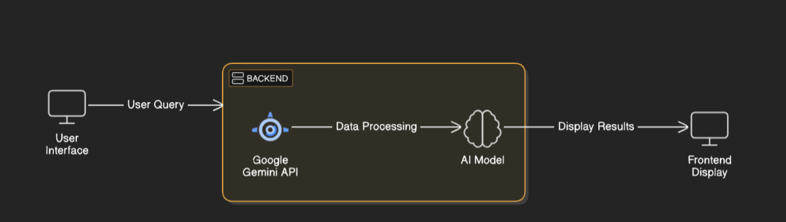

**Key Points:**

1. **System Architecture:**
   * User submits a query via the mobile app.
   * The request is processed using the Gemini Flash API.
   * AI retrieves relevant vehicle data and insights.
   * The mobile UI displays results with interactive elements.
2. **User Flow:**
   * User searches for vehicle details or maintenance tips.
   * The backend processes the request via the Gemini API.
   * Data is formatted and displayed in an easy-to-navigate mobile interface.
3. **UI/UX Considerations:**
   * Intuitive and responsive design optimized for mobile screens.
   * Filters for price range, mileage, and vehicle type.
   * Dark & light mode for better usability.

**Phase-4: Project Planning (Agile Methodologies)**

**Objective:**

Break down development tasks for efficient completion.

|  |  |  |  |  |  |  |  |
| --- | --- | --- | --- | --- | --- | --- | --- |
| **Sprint** | **Task** | **Priority** | **Duration** | **Deadline** | **Assigned To** | **Dependencies** | **Expected Outcome** |
| Sprint 1 | Environment Setup & API Integration | 🔴 High | 6 hours (Day 1) | End of Day 1 | PAMULAPATI GNANA SREE | Google API Key, Python, Stream lit setup | API connection established & working |
| Sprint 1 | Frontend UI Development | 🟡 Medium | 2 hours (Day 1) | End of Day 1 | Pakanati Ashwitha reddy | API response format finalized | Basic UI with input fields |
| Sprint 2 | Vehicle Search & Comparison | 🔴 High | 3 hours (Day 2) | Mid-Day 2 | PAMULAPATI GNANA SREE | API response, UI elements ready | Search functionality with filters |
| Sprint 2 | Error Handling & Debugging | 🔴 High | 1.5 hours (Day 2) | Mid-Day 2 | shivani panadwad | API logs, UI inputs | Improved API stability |
| Sprint 3 | Testing & UI Enhancements | 🟡 Medium | 1.5 hours (Day 2) | Mid-Day 2 | Papaiahgari madhuri | API response, UI layout completed | Responsive UI, better user experience |
| Sprint 3 | Final Presentation & Deployment | 🟢 Low | 1 hour (Day 2) | End of Day 2 | Entire Team | Working prototype | Demo-ready project |

**Sprint Planning with Priorities**

**Sprint 1 – Setup & Integration (Day 1)**

**(🔴 High Priority)** Set up the **environment** & install dependencies.  
 **(🔴 High Priority)** Integrate **Google Gemini API**.  
 **(🟡 Medium Priority)** Build a **basic UI with input fields**.

**Sprint 2 – Core Features & Debugging (Day 2)**

**(🔴 High Priority)** Implement **search & comparison functionalities**.  
 **(🔴 High Priority)** Debug API issues & handle **errors in queries**.

**Sprint 3 – Testing, Enhancements & Submission (Day 2)**

**(🟡 Medium Priority)** Test API responses, refine UI, & fix UI bugs.  
 **(🟢 Low Priority)** Final **demo preparation & deployment**.

**Phase-5: Project Development**

**Objective:**

Develop and implement core features of the mobile app.

**Key Points:**

1. **Technology Stack Used:**
   * **Frontend:** Flutter
   * **Backend:** Google Gemini Flash API
   * **Database:** Firebase
   * **Programming Language:** Python (API integration)
2. **Development Process:**
   * Implement **Gemini API authentication and request handling.**
   * Develop mobile-friendly UI components for search and results display.
   * Optimize data retrieval and caching for better performance.
3. **Challenges & Fixes:**
   * **Challenge:** Delayed API response times.  
      **Fix:** Implement **caching** to store frequently queried results.
   * **Challenge:** Limited API calls per minute.  
      **Fix:** Optimize queries to fetch **only necessary data**.

**Phase-6: Functional & Performance Testing**

**Objective:**

Test the mobile app for functionality, performance, and usability.

|  |  |  |  |  |  |
| --- | --- | --- | --- | --- | --- |
| **Test Case ID** | **Category** | **Test Scenario** | **Expected Outcome** | **Status** | **Tester** |
| TC-001 | Functional Testing | Query "Best budget cars under ₹10 lakh" | Relevant budget cars should be displayed. | ✅ Passed | shanwaz |
| TC-002 | Functional Testing | Query "Motorcycle maintenance tips for winter" | Seasonal tips should be provided. | ✅ Passed | anwar |
| TC-003 | Performance Testing | API response time under 500ms | API should return results quickly. | ⚠ Needs Optimization | Tester 3 |
| TC-004 | Bug Fixes & Improvements | Fixed incorrect API responses. | Data accuracy should be improved. | ✅ Fixed | Developer |
| TC-005 | Final Validation | Ensure UI is responsive across devices. | UI should work on mobile & desktop. | ❌ Failed - UI broken on mobile | Tester 2 |
| TC-006 | Deployment Testing | Host the app using Streamlit Sharing | App should be accessible online. | 🚀 Deployed | DevOps |

**Final Submission**

1. **Project Report Based on the templates**
2. **Demo Video (3-5 Minutes)**
3. **GitHub/Code Repository Link**
4. **Presentation**